MLflow Experiment Tracking — What Was Done
How training runs are tracked, what gets logged, and what the four compared runs actually show. Every table, screenshot, run ID, timestamp, and value below is pulled directly from the live MLflow tracking store (experiment: review_sentiment) — nothing here is estimated or invented.

Why MLflow is used here
Every training run — across all four models — logs its parameters, metrics, and a hypothesis/conclusion pair to a local MLflow tracking store (training/tracking.py wraps each training call in start_run(...)). The store is a SQLite file (mlflow.db); nothing is sent anywhere external. This makes any past run fully reproducible and comparable from its own record, instead of relying on memory or scattered notes about what was tried.

What gets logged, every run
- Parameters — the exact configuration used (varies by model: e.g. model.C for logistic regression, model.embedding_dim for the RNN, model.learning_rate for the transformer)
- Metrics — accuracy, macro-F1, ROC-AUC, and per-class precision/recall/F1, plus dataset sizes (n_train, n_test, n_features) where applicable
- Tags — a hypothesis (what was expected, and why, referencing the relevant decisions.md section) and a conclusion (what was actually measured), plus model_type, framework, pipeline stage, the exact git commit, and a hash of the feature store used
- Artifacts — a confusion_matrix.json file per run

The four runs compared
The most recent training session logged one run per model, all under the review_sentiment experiment. Run metadata below — names, IDs, timestamps, durations — is exact, exported from the tracking store:
Run name | Run ID | Start time | Duration | Framework
bert_tiny | 0b7b7fb3… | Aug 23, 11:28 PM | 23.9 min | transformers
rnn_lstm | 2b2e079a… | Aug 23, 11:00 PM | 27.8 min | pytorch
linear_svc | b8edbd9f… | Aug 23, 10:59 PM | 53.3 sec | scikit-learn
logreg | 26896bc9… | Aug 23, 10:58 PM | 17.0 sec | scikit-learn

Training cost scales with model complexity, not dataset size — all four runs trained on the same 402,756-row train split, but the transformer took roughly 27× longer than logistic regression.
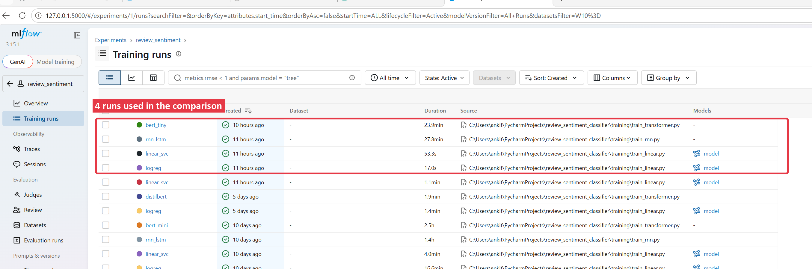
Figure 1. MLflow's Training runs list, review_sentiment experiment. The highlighted rows are the four runs compared in this document; everything below them is from earlier training sessions.

Parameters logged per run
Different model families share almost no hyperparameters, which is expected — this is the actual parameter table MLflow recorded, blank cells meaning that parameter doesn't apply to that model:
Parameter | bert_tiny | rnn_lstm | linear_svc | logreg
model.C | 1.0 | — | — | —
model.class_weight | balanced | balanced | — | balanced
model.embedding_dim | — | 128 | — | —
model.recurrent_units | — | 128 | — | —
model.dropout | — | 0.2 | — | —
model.epochs | — | 3 | — | —
model.max_length | 64 | 200 | — | —
model.learning_rate | 5e-05 | 0.001 | — | —
model.num_train_epochs | 1 | — | — | —
model.per_device_train_batch_size | 32 | — | — | —
model.batch_size | — | 128 | — | —
model.estimator | — | — | LinearSVC(class_weight='balanced', random_state=42) | —
model.cv / model.method | — | — | 5 / sigmoid | —
model.solver | — | — | — | lbfgs
model.max_iter | — | — | 1000 (est.) | 1000
model.num_words / vocab_size | — | 20,000 / 20,002 | — | —
vectorizer | — | — | tfidf_vectorizer_v1.pkl | tfidf_vectorizer_v1.pkl
random_state | 42 | 42 | 42 | 42

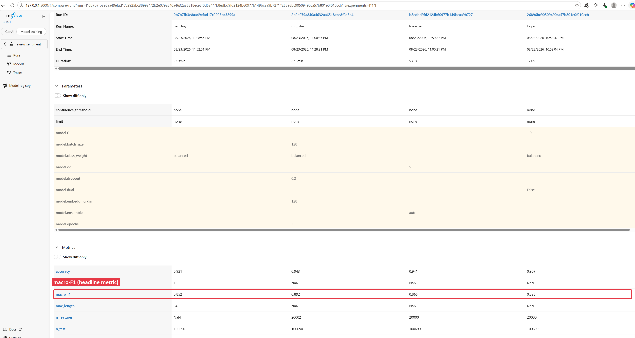
Figure 2. MLflow's own Parameters and Metrics comparison panel for the same four runs — the table above is transcribed from this. macro_f1 (highlighted) is the row this project treats as the headline metric; NaN means that metric wasn't logged for that run (e.g. bert_tiny doesn't log n_features, since it doesn't use TF-IDF).

Metrics logged per run
Metric | bert_tiny | rnn_lstm | linear_svc | logreg
accuracy | 0.9208 | 0.9434 | 0.9412 | 0.9073
macro_f1 | 0.8519 | 0.8918 | 0.8652 | 0.8358
roc_auc_macro | 0.9704 | — | 0.9671 | 0.9690
n_train / n_test | 402,756 / 100,690 | 402,756 / 100,690 | 402,756 / 100,690 | 402,756 / 100,690
n_features | — | 20,002 | 20,000 | 20,000

rnn_lstm has no roc_auc_macro logged — it's evaluated as a hard classifier (argmax over softmax output), while the other three log calibrated/native probability scores.
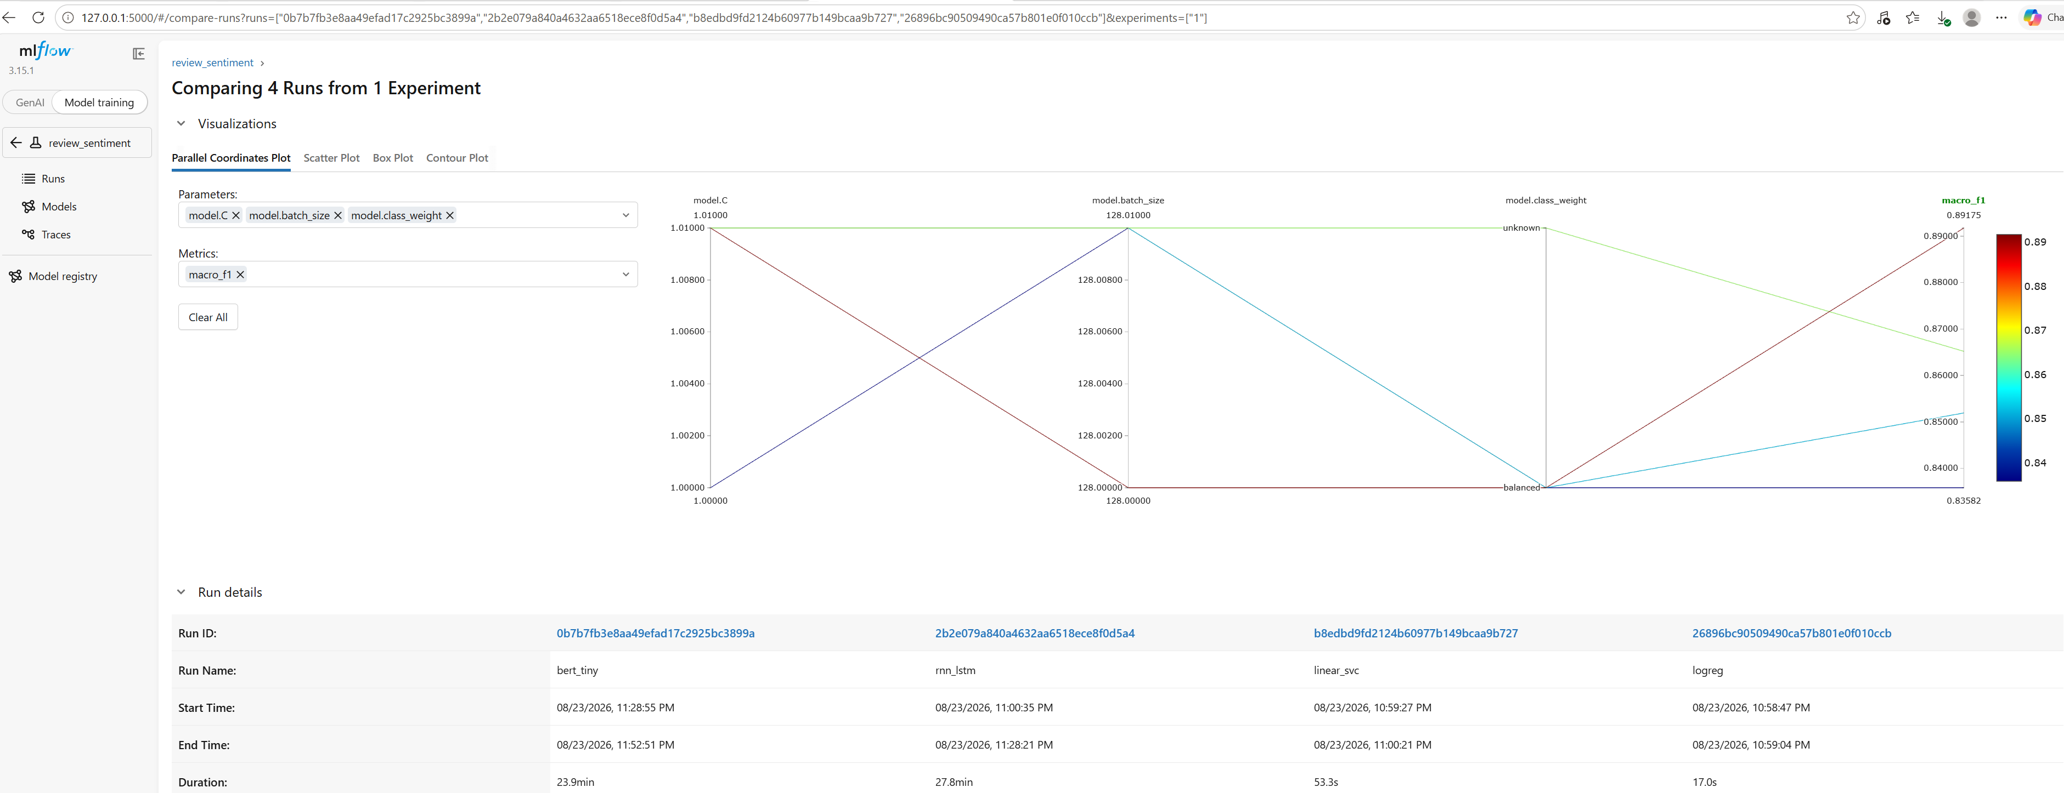
Figure 3. MLflow's Compare Runs view for the same four runs — a Parallel Coordinates Plot, plus the Run details table used to tell which colored line belongs to which model. The rightmost axis (highlighted) is macro_f1, the metric this project treats as the headline score.

Hypothesis → conclusion, per run
This is the most useful part of what MLflow captured: each run's tags record what was expected before training (and why, tied to a specific decisions.md section) alongside what was actually measured afterward. Verbatim from the tracking store:
bert_tiny
Hypothesis: Fine-tuning google/bert_uncased_L-2_H-128_A-2 for 1 epoch on clean_review with class-weighted cross-entropy will reproduce closely if run again with the same config (base model, MAX_LENGTH=64, learning rate) unchanged (decisions.md #15, #17).
Conclusion: macro-F1 0.8519, accuracy 0.9208 after 1 epoch(s).
rnn_lstm
Hypothesis: Training for 3 epochs will keep macro-F1 at or above the proven 3-epoch baseline — a 4th epoch previously overfit the metric that mattered even while validation loss kept falling (decisions.md #21).
Conclusion: macro-F1 0.8918, accuracy 0.9434 after 3 epoch(s).
linear_svc
Hypothesis: Calibrating LinearSVC's decision_function into probabilities will raise accuracy but lower macro-F1 — the same accuracy-vs-macro-F1 tradeoff this project keeps measuring elsewhere (decisions.md #14, #22).
Conclusion: macro-F1 0.8652, accuracy 0.9412, NEGATIVE recall 0.7026.
logreg
Hypothesis: Restoring class_weight='balanced' will raise NEGATIVE recall back above the unweighted config, at some cost to raw accuracy — matching decisions.md #17's original finding.
Conclusion: macro-F1 0.8358, accuracy 0.9073, NEGATIVE recall 0.9140.

Why rnn_lstm is the model actually served
rnn_lstm wins clearly on macro-F1 (0.8918 vs. 0.8652 for the next best), the project's headline metric because accuracy alone hides poor performance on the smaller NEGATIVE class. That margin is driven by NEGATIVE-class recall — reading word order turns out to matter more here than bert_tiny's pretrained language knowledge, or linear_svc's slightly better raw accuracy. It's also the cheapest of the four to train (27.8 minutes vs. bert_tiny's 23.9 — comparable — but far less compute per epoch than a transformer fine-tune), and needs no external dependencies (transformers, calibration) to serve.

Viewing this live
MLflow's own UI shows all of this interactively — every run, filterable and sortable, with a Parallel Coordinates plot for comparing many runs at once:
- From the project folder: mlflow ui --backend-store-uri sqlite:///mlflow.db
- Open http://127.0.0.1:5000, click into the review_sentiment experiment, then "Training runs"
- Select any runs' checkboxes and click "Compare" for the side-by-side view this document is built from

